POWER CURVE
VERSION 2

GRAPHICAL COMPUTER INTERFACE FOR ROLLING ROADS

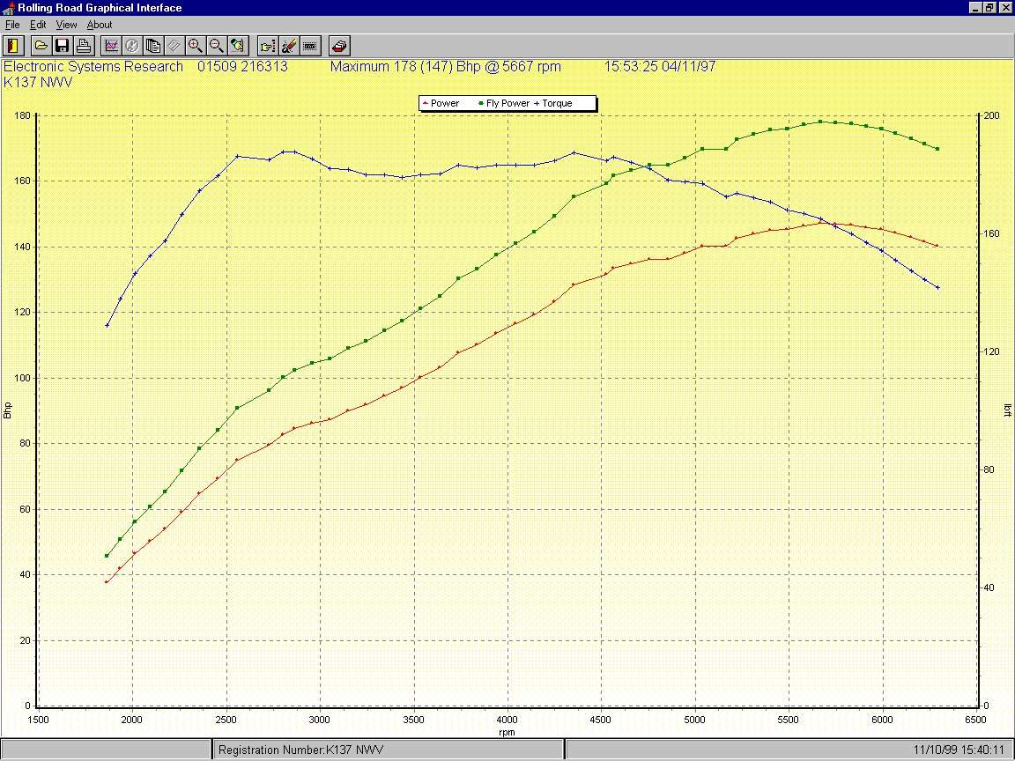

INTRODUCTION

The Power Curve Graphical Interface is designed to complement and enhance the performance of rolling roads. It does this by producing a graph of the car’s power as the car is accelerated on the rolling road. This graph can be stored, along with many details about the car.

For tuning cars this approach has several benefits:

- The runs are very quick, typically 10 to 30 seconds. This is much quicker than taking down readings by hand.
- The runs are more accurately repeatable than taking readings by hand.
- Power readings are typically taken every 20 rpm.
- The data can be stored to compare runs.
- Before and after runs can be printed off for your customer.
- Details of the car set up can be stored for future reference.

These benefits result in:

- More rapid cycles of tuning and testing. Small adjustments can be made repeatedly and tested to see if they have the expected effect.
- Thermal stresses on the engine under test are reduced.
- Close spacing of the readings and repeatability of the runs mean that improvements or problems can be seen which would otherwise be difficult to assess.
- The customer has visual evidence of their car’s performance and the improvements you have made.
- The car’s performance can be compared from one visit to the next.

POWER CURVE

Version 2 of Electronic Systems Research’s Power Curve Graphical Interface software provides the most sophisticated tools yet developed for data capture, analysis and storage using your Rolling Road.

Like version 1, it maintains it’s advantage in speed of acquisition and sensitivity to give the most detailed Power Curves available. In addition it also has the following new features:

- All new Windows graphical interface with simple to use point and click commands. The visual impact of this software will wow! your customers.
- High quality colour printer output, using standard Windows printer drivers.
- Fully configurable graph axes. Once you have acquired your data for a run, the display can be changed at the click of a button to show rpm, speed, time, power and torque in any combination. You can, for instance, produce a Power Curve and an acceleration curve for your customer from the same run.
- Configurable units. You can display power, speed and torque in a variety of units, even changing units after you have done a run. You can, for instance, switch from miles per hour to kilometres per hour with a few mouse clicks.
- Backup and restore facilities to allow you to save data to floppy disk or even another computer. No more worries about lost data from a computer crash. This is again configurable so that, for instance, a customer could be given a disk of all the runs done on his car this year. This also allows the system to be cleared out at year end, cutting down clutter and saving disk space.
- User configurable defaults for colours, axes, data directories and display options. You can change the look and feel of the program so that it starts up how you want it to.
- Full password protection to stop unauthorised tampering.
- Easy to produce reports on any car’s history of runs.

The new Power Curve Graphical Interface will enable you to produce reports on engine tuning in exactly the format your customer requires with the minimal amount of time and effort expended, increasing the time that can be spent actually tuning the engine. It will improve your productivity and throughput on the rolling road and give increased customer satisfaction.

SYSTEM REQUIREMENTS

- 486 or higher IBM compatible Personal Computer.
- Windows 3.1, Windows 95 or Windows NT.
- 4Mb RAM minimum (8Mb recommended).
- 5Mb hard disk space.
- Screen resolution of at least 800 x 600. (The program will work with less than this, but the graph will become very cramped).
- Monochrome or colour printer is desirable.

INSTALLATION

- If you are running from floppy disks, put disk 1 into the a: drive. If you are installing from cd rom, put the disk int your cd drive.

Windows 3.1
- From Windows Program Manager click File then Run.
- Type into the command box drive_letter:setup where drive letter is “a” for the floppy drive and probably “d” for your cd rom.

Windows 95/98/NT
- Click Start then Run.
- Click OK.

All operating systems
- Follow the on-screen instructions. We recommend accepting the default directories.
- At the end of the installation the computer needs to be restarted. Remove the floppy disk from the a: drive before clicking OK.
- To start the program:

Windows 3.1
- From Windows Program Manager, click on the icon labelled Power Curve Graphical Interface.

Windows 95/98/NT
- Click Start then Programs then Power Curve and finally select the Power Curve Graphical Interface.

This will bring you to a blank front graph screen.

OPERATION

The operation of the software is generally intuitive. Leaving the cursor over any of the buttons on the toolbar for a short while will cause a hint of the button’s action to be displayed.

Runs are stored and organised based on the car’s registration number.

It is not possible to perform actual Power Curve runs with this software. That requires additional electronics to interface to the rolling road and pick up the rpm from the engine. There are however demonstration runs stored on the computer. These can be used to get a general idea of how to use the software. To perform the runs in the full version, a button is supplied which can be operated by the user seated in a car. This means that it is only necessary to have one operator to perform the runs.

Opening a Run

- To display a previously saved run, click on the open button or select File then Open from the menu.
- If you have not already selected a registration number, you will be prompted to select one. Double clicking on the desired registration, or clicking OK when the registration is highlighted selects that registration, and the selected registration number appears at the bottom of the screen.
A list of runs saved for that registration number will be displayed. These are shown in date order, oldest first. Double clicking on the desired run, or clicking OK when the run is highlighted selects that run, and the selected run will then be displayed on the screen.

Zooming In

- The run may not occupy the whole of the graph, or may even be off the top of the axes.
- To zoom in so that the run occupies the whole graph either click with the mouse at the bottom right of an imaginary rectangle, and holding the mouse button down move to the top left corner of the imaginary rectangle, then let the mouse button go (this is much easier to do than to describe! A thin red line shows the rectangle while you are dragging the mouse) or click the zoom full button.
- To zoom in to a specific area of the curve, do the opposite of the zoom full. Click on the top left of an imaginary rectangle and drag to the bottom right. The graph will zoom in to the rectangle selected. If you zoom in too far, simply zoom back to the full graph and start again.
- To view the axis zoom tool, click View then Axis Zoom Tool. This tool will appear at the top right of the screen.
- The axis zoom tool can be used to shift the display of one axis at a time. Try clicking on the buttons. If you click with the right mouse button on the axis zoom tool, you are given the option of closing the tool or showing it by default at start up.

Printing

- The Windows printer drivers for your printer must be installed. To check if they have been, click File followed by Print Setup. This will give you a list of installed printers to choose from.
- When a printer is connected, click the print button or click File followed by Print.
- Note that the background changes to white during printing to conserve ink.

Customising Axes

- To customise what is shown on each axis click the edit axes button or Edit then Axes from the menu.
- The options for each axis are shown in drop down boxes. Try reconfiguring the axes for an acceleration run, with time on the X axis, mph on one Y axis and bhp on the other. Clicking OK will redisplay the graph as you have selected it.

Overlaying Runs

- To show two runs, one on top of the other, click the Overlay button.
- The run you have on screen will then change to the overlay colours. You can then either click the Open button to display another run for the same car, or click the Select Registration button to choose a different car before clicking the Open button and selecting a run for that car. If the display looks rather messy with two runs overlaid, try clicking Edit then Axes and deselecting the Show Points check box. To show only the latest run again, click the Clear Overlay button.

Setting Defaults

- To see how the default setup can be changed click Edit then Defaults. Any of the options on the six pages here can be changed and their effect seen on the displayed graph.
- Setting the language is a little more complicated. To avoid accidentally changing the language, this option has not been added to the GUI, and so cannot be set from the program. At present only two languages are supported, English and German. To change the language requires the initialisation file to be edited. This file is in your windows directory. To edit it go to the windows directory and double click rr.ini, opening it in a text editor such as notepad. You will see an entry in the file like this:

[Translate]
Language=English

Edit this line to read either Language=English or Language=German. Then save the file and restart the Power Curve application. All menu settings, buttons etc should then be in the required language.

These are just a quick sample of what can be done with version 2 of Power Curve. If you need any further information contact Electronic Systems Research.

